Assignment 7.2

1. Write a program to create barplots for all the categorical columns in mtcars.

Solution:

library(purrr)

library(tidyr)

library(ggplot2)

mtcars %>%

keep(is.numeric) %>%

gather() %>%

ggplot(aes(value)) +

facet_wrap(~ key, scales = "free") +

geom_bar()

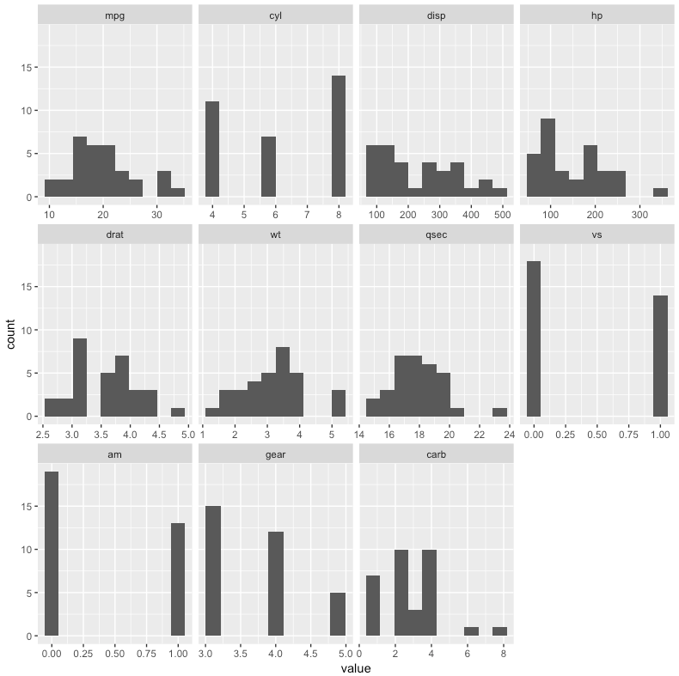

2. Create a scatterplot matrix by gear types in mtcars dataset.